Order Of Service

Singing: Psalm 51a—CW page 86

Reading: Psalm 108

Opening Hymn: TLH 62

Reading: Acts 27:1-12

Request Hymn: CW Supplement 707

Reading: Matthew 12:22-37

Sermon Hymn: TLH 605

Sermon Text: Mark 11:27-33

No Answer

Prayer

The Apostles’ Creed, TLH page 12

Holy Communion

The Lord's Prayer

The Blessing

Closing Hymn: TLH 50

* * * * * * * * * * *
Bible Study: Lambs: Woodchuck (Groundhog)
Sheep: Proverbs 21:26-31
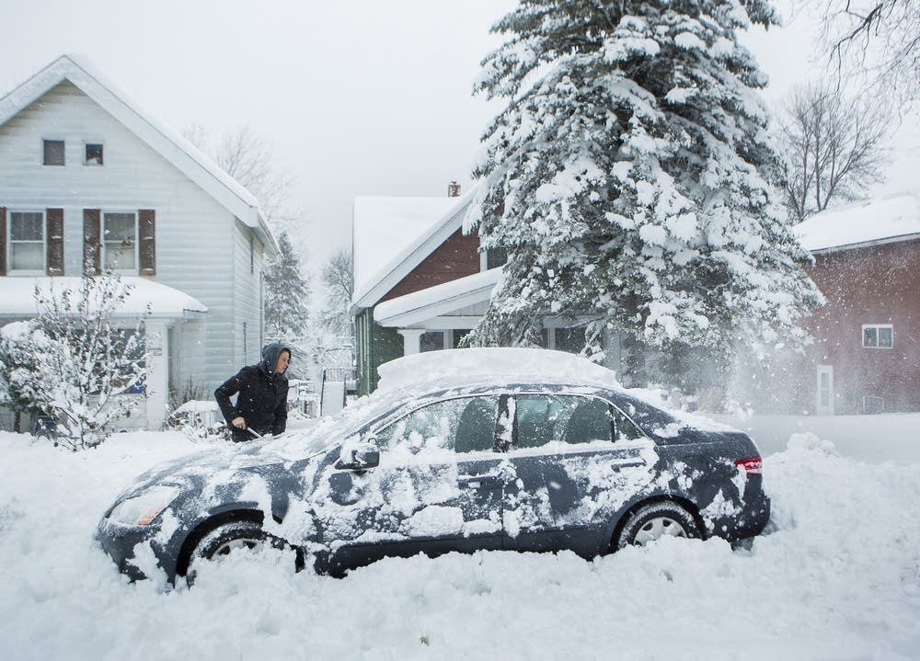

Winter Memories In Duluth

Water
Of
Life
29 December 2019

W A T E R O F L I F E

Independent Christian Church—Conservative Lutheran Doctrine

Worship Service: 9:30 a.m. Bible Study: 10:45 a.m.

Larry Cooper, Pastor E-Mail address:
111 N. Ridge Road lcooper@wateroflife.cc
Coon Valley, WI 54623 Web Site:
www.wateroflife.cc

* * * * * * * * * * * * * * * * * * * * * * * * * * *

Sermon Text: Mark 11:27-33

No Answer

* * * * * * * * * * * * * * * * * * * * * * * * * * *

Mark 11:27 And they come again to Jerusalem: and as he was walking in the temple, there come to him the chief priests, and the scribes, and the elders,
:28 And say unto him, By what authority doest thou these things? and who gave thee this authority to do these things?
:29 And Jesus answered and said unto them, I will also ask of you one question, and answer me, and I will tell you by what authority I do these things.
:30 The baptism of John, was it from heaven, or of men? answer me.
:31 And they reasoned with themselves, saying, If we shall say, From heaven; he will say, Why then did ye not believe him?
:32 But if we shall say, Of men; they feared the people: for all men counted John, that he was a prophet indeed.
:33 And they answered and said unto Jesus, We cannot tell. And Jesus answering saith unto them, Neither do I tell you by what authority I do these things.

